Project 20: Web Forms

Objectives:

At the end of this project, you will be able to:
- Create a web form in an XHTML document.
- Populate a form with common input elements.
- Use CSS to organize and style a form.

Instructions:

- Create a new folder called "Web Forms".
- Create a new XHTML document and save it as "index.html" in the "Forms" folder.
- Set the title to be "Web Form".
- Create a form that uses the “post” method with an action of "index.html".
- By using an internal CSS style sheet, without tables, re-create the following form as closely as you can:
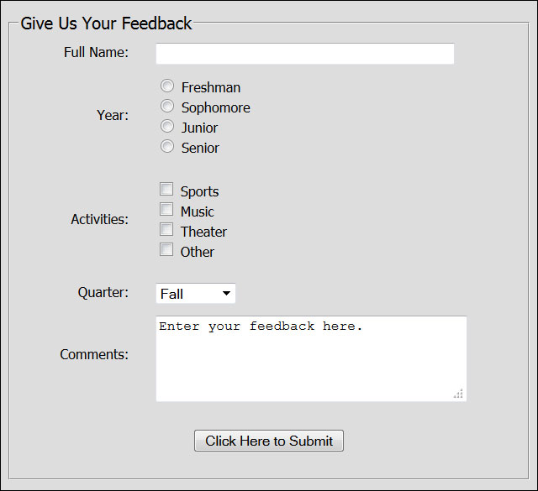
- Requirement #1: The drop-down list options are Spring, Summer, Fall, and Winter, in that order. Set it so that Fall is preselected in the form.
- Requirement #2: Use a class to apply the following properties to the form element: width (500px), background-color, padding, border, font-family (Tahoma), and font-size.
- Requirement #3: Use a class to apply the following properties to all the text labels in the left column: width (100px), text-align, float, padding, and margin-right.
- Requirement #4: Use a class to apply the following properties to all the form inputs in the right column: text-align and padding.
- Requirement #5: Create a class to clear the float and use it between each form section.
- Requirement #6: Create a class for the button with the following properties set: text-align, padding.
- Final Requirement: In order to get the Year, Activities, and Comments labels to center horizontally, create a special class with height and padding-top defined. To make this work, you will need to apply two classes to some elements.

Rubric 20: Web Forms

Name: ____________________________

Component | Possible Points | Score
The form element has the action and method attributes defined. | 1
All styling is accomplished with an internal CSS style sheet with no tables or inline styles. | 1
The form has a background color set, has a border, and is 500px in width. | 2
The labels on the left are 100px wide, floated left, and text-aligned right. | 2
The labels on the left column all use the same class and have a right margin set to create some space between the labels and the form input elements. | 2
The form elements on the right column all use the same class and are text-aligned to the left. | 2
After each form element, the float is cleared. | 2
The submit button is centered and has padding defined. | 2
The Year, Activities, and Comments labels have a second class defined for them which sets the height and defines top padding. | 2
Fieldset and legend elements have been added and appear as shown. | 2
The text box element has the correct syntax. | 2
The radio button elements have the correct syntax. | 2
The checkbox elements have the correct syntax. | 2
The drop-down list element has the correct syntax and Fall has been preselected. | 3
The textarea element has the correct syntax and has the indicated text already placed in it. | 2
The overall form appears reasonably similar to the target form from the instructions. | 4
Total Score | 33

